Lab - Troubleshoot OSPFv3

# Topology

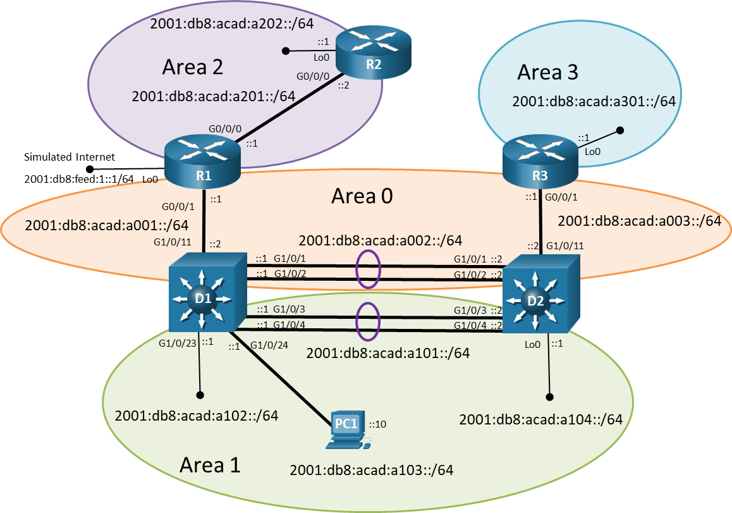

# Addressing Table

| Device | Interface | IPv6 Address | Link-Local |
| --- | --- | --- | --- |
| R1 | G0/0/0 | 2001:db8:acad:a201::1/64 | fe80::a201:1 |
| R1 | G0/0/1 | 2001:db8:acad:a001::1/64 | fe80::a001:1 |
| R1 | Lo1 | 2001:db8:feed:1::1/64 | fe80::1:1 |
| R2 | G0/0/0 | 2001:db8:acad:a201::2/64 | fe80::a201:2 |
| R2 | Lo1 | 2001:db8:acad:a202::1/64 | fe80::a202:1 |
| R3 | G0/0/1 | 2001:db8:acad:a003::1/64 | fe80::a003:1 |
| R3 | Lo1 | 2001:db8:acad:a301::1/64 | fe80::a301:1 |
| D1 | G1/0/1 (Po1) | 2001:db8:acad:a002::1/64 | fe80::a002:1 |
| D1 | G1/0/2 (Po1) | 2001:db8:acad:a002::1/64 | fe80::a002:1 |
| D1 | G1/0/3 (Po2) | 2001:db8:acad:a101::1/64 | fe80::a101:1 |
| D1 | G1/0/4 (Po2) | 2001:db8:acad:a101::1/64 | fe80::a101:1 |
| D1 | G1/0/5 | 2001:db8:acad:a103::1/64 | fe80::a103:1 |
| D1 | G1/0/11 | 2001:db8:acad:a001::2/64 | fe80::a001:2 |
| D1 | G1/0/23 | 2001:db8:acad:a102::1/64 | fe80::a102:1 |
| D2 | G1/0/1 (Po1) | 2001:db8:acad:a002::2/64 | fe80::a002:2 |
| D2 | G1/0/2 (Po1) | 2001:db8:acad:a002::2/64 | fe80::a002:2 |
| D2 | G1/0/3 (Po2) | 2001:db8:acad:a101::2/64 | fe80::a101:2 |
| D2 | G1/0/4 (Po2) | 2001:db8:acad:a101::2/64 | fe80::a101:2 |
| D2 | G1/0/11 | 2001:db8:acad:a003::2/64 | fe80::a003:2 |
| D2 | Lo0 | 2001:db8:acad:a104::1/64 | fe80::a104:1 |
| PC1 | N/A | SLAAC | SLAAC |

**Note**: To make it easier to recognize IPv6 prefixes, familiarize yourself with the IPv6 GUA and LLA address formats.

* **GUA**: The GUA has a 16-bit subnet-ID, a<area-id>xx ("a" for area). For example, subnet-ID a201 is area 2, network 01.
* **LLA**: Following best practice the LLA address is unique on each interface. The LLA interface-ID uses the GUA subnet-ID:interface-ID for the last 64 bits. For example, fe80::a201:1 has an LLA interface-ID a201 (the subnet-ID of the GUA) and :1 (the Interface ID of the GUA).

# Objectives

Troubleshoot network issues related to the configuration and operation of OSPFv3.

# Background / Scenario

Although the topology has a limited number of routers, you should use the appropriate troubleshooting commands to help find and solve the problems in the three trouble tickets as if this were a much more complex topology with many more routers and networks.

You will be loading configurations with intentional errors onto the network. Your tasks are to FIND the error(s), document your findings and the command(s) or method(s) used to fix them, FIX the issue(s) presented here and then test the network to ensure both of the following conditions are met:

* + - * 1. the complaint received in the ticket is resolved
        2. full reachability is restored

**Note**: The routers used with CCNP hands-on labs are Cisco 4221 with Cisco IOS XE Release 16.9.4 (universalk9 image). The switches used in the labs are Cisco Catalyst 3650 with Cisco IOS XE Release 16.9.4 (universalk9 image). Other routers, switches, and Cisco IOS versions can be used. Depending on the model and Cisco IOS version, the commands available and the output produced might vary from what is shown in the labs. Refer to the Router Interface Summary Table at the end of the lab for the correct interface identifiers.

**Note**: Make sure that the devices have been erased and have no startup configurations. If you are unsure, contact your instructor.

# Required Resources

* 3 Routers (Cisco 4221 with Cisco IOS XE Release 16.9.4 universal image or comparable)
* 2 Switches (Cisco 3560 with Cisco IOS XE Release 16.9.4 universal image or comparable)
* 1 PC (Choice of operating system with terminal emulation program installed)
* Console cables to configure the Cisco IOS devices via the console ports
* Ethernet cables as shown in the topology

# Instructions

## Trouble Ticket 10.1.2.1

Scenario:

Your University network has migrated to IPv6-only internally and is using multiarea OSPFv3 address families. Recently your team configured all the necessary devices for this migration, with different people responsible for configuring different parts of the network.

During testing and validation, the network team noticed that routers are not showing the 2001:db8:acad:a202::/64 prefix in their routing tables.

Use the commands listed below to load the configuration files for this trouble ticket:

|  |  |
| --- | --- |
| Device | Command |
| R1 | **copy flash:/enarsi/10.1.2.1-r1-config.txt run** |
| R2 | **copy flash:/enarsi/10.1.2.1-r2-config.txt run** |
| R3 | **copy flash:/enarsi/10.1.2.1-r3-config.txt run** |
| D1 | **copy flash:/enarsi/10.1.2.1-d1-config.txt run** |
| D2 | **copy flash:/enarsi/10.1.2.1-d2-config.txt run** |

* All routers should have the 2001:db8:acad:a202::/64 network in their routing tables.
* All devices should be able to ping 2001:db8:acad:a202::2/64.
* When you have fixed the ticket, change the MOTD on EACH DEVICE using the following command:

**banner motd # This is $(hostname) FIXED from ticket <ticket number> #**

* Save the configuration by issuing the **wri** command (on each device).
* Inform your instructor that you are ready for the next ticket.
* After the instructor approves your solution for this ticket, issue the **reset.now** privileged EXEC command. This script will clear your configurations and reload the devices.

## Trouble Ticket 10.1.2.2

Scenario:

After a regularly scheduled downtime for maintenance and IOS upgrades, users started reporting to the helpdesk that there is no access to the IPv6 prefix in area 3. Although there are backups for all device configurations it is suspected that there some of the backups might not have been correct.

You have been tasked to find and resolve the issue with reaching the IPv6 prefix in area 3.

Use the commands listed below to load the configuration files for this trouble ticket:

|  |  |
| --- | --- |
| Device | Command |
| R1 | **copy flash:/enarsi/10.1.2.2-r1-config.txt run** |
| R2 | **copy flash:/enarsi/10.1.2.2-r2-config.txt run** |
| R3 | **copy flash:/enarsi/10.1.2.2-r3-config.txt run** |
| D1 | **copy flash:/enarsi/10.1.2.2-d1-config.txt run** |
| D2 | **copy flash:/enarsi/10.1.2.2-d2-config.txt run** |

* All routers should have the 2001:db8:acad:a301::/64 network in their routing tables.
* All devices should be able to ping 2001:db8:acad:a301::1/64.
* When you have fixed the ticket, change the MOTD on EACH DEVICE using the following command:

**banner motd # This is $(hostname) FIXED from ticket <ticket number> #**

* Then save the configuration by issuing the **wri** command (on each device).
* Inform your instructor that you are ready for the next ticket.
* After the instructor approves your solution for this ticket, issue the **reset.now** privileged EXEC command. This script will clear your configurations and reload the devices.

## Trouble Ticket 10.1.2.3

Scenario:

Network technicians recently installed a new router, R2 to area 2. However, during the verification phase the technicians are reporting that the other routers are not including the 2001:db8:acad:a202::/64 prefix in their routing tables. They call you for assistance.

Use the commands listed below to load the configuration files for this trouble ticket:

|  |  |
| --- | --- |
| Device | Command |
| R1 | **copy flash:/enarsi/10.1.2.3-r1-config.txt run** |
| R2 | **copy flash:/enarsi/10.1.2.3-r2-config.txt run** |
| R3 | **copy flash:/enarsi/10.1.2.3-r3-config.txt run** |
| D1 | **copy flash:/enarsi/10.1.2.3-d1-config.txt run** |
| D2 | **copy flash:/enarsi/10.1.2.3-d2-config.txt run** |

**Note**: To simulate the link being cut, shutdown the G0/0/1 interface on R3:

* PC1 should be able to ping 2001:db8:acad:a301::1.
* Network 2001:db8:acad:a301::/64 must be in its own area.
* When you have fixed the ticket, change the MOTD on EACH DEVICE using the following command:

**banner motd # This is $(hostname) FIXED from ticket <ticket number> #**

* Save the configuration by issuing the **wri** command (on each device).
* Inform your instructor that you are ready for the next ticket.
* After the instructor approves your solution for this ticket, issue the **reset.now** privileged EXEC command. This script will clear your configurations and reload the devices.

# Router Interface Summary Table

| Router Model | Ethernet Interface #1 | Ethernet Interface #2 | Serial Interface #1 | Serial Interface #2 |
| --- | --- | --- | --- | --- |
| 1800 | Fast Ethernet 0/0 (F0/0) | Fast Ethernet 0/1 (F0/1) | Serial 0/0/0 (S0/0/0) | Serial 0/0/1 (S0/0/1) |
| 1900 | Gigabit Ethernet 0/0 (G0/0) | Gigabit Ethernet 0/1 (G0/1) | Serial 0/0/0 (S0/0/0) | Serial 0/0/1 (S0/0/1) |
| 2801 | Fast Ethernet 0/0 (F0/0) | Fast Ethernet 0/1 (F0/1) | Serial 0/1/0 (S0/1/0) | Serial 0/1/1 (S0/1/1) |
| 2811 | Fast Ethernet 0/0 (F0/0) | Fast Ethernet 0/1 (F0/1) | Serial 0/0/0 (S0/0/0) | Serial 0/0/1 (S0/0/1) |
| 2900 | Gigabit Ethernet 0/0 (G0/0) | Gigabit Ethernet 0/1 (G0/1) | Serial 0/0/0 (S0/0/0) | Serial 0/0/1 (S0/0/1) |
| 4221 | Gigabit Ethernet 0/0/0 (G0/0/0) | Gigabit Ethernet 0/0/1 (G0/0/1) | Serial 0/1/0 (S0/1/0) | Serial 0/1/1 (S0/1/1) |
| 4300 | Gigabit Ethernet 0/0/0 (G0/0/0) | Gigabit Ethernet 0/0/1 (G0/0/1) | Serial 0/1/0 (S0/1/0) | Serial 0/1/1 (S0/1/1) |

**Note**: To find out how the router is configured, look at the interfaces to identify the type of router and how many interfaces the router has. There is no way to effectively list all the combinations of configurations for each router class. This table includes identifiers for the possible combinations of Ethernet and Serial interfaces in the device. The table does not include any other type of interface, even though a specific router may contain one. An example of this might be an ISDN BRI interface. The string in parenthesis is the legal abbreviation that can be used in Cisco IOS commands to represent the interface.

End of document